Task 0 :
- Install and configure of GitHub Copilot Take Screenshot of each one.
- Expected output :

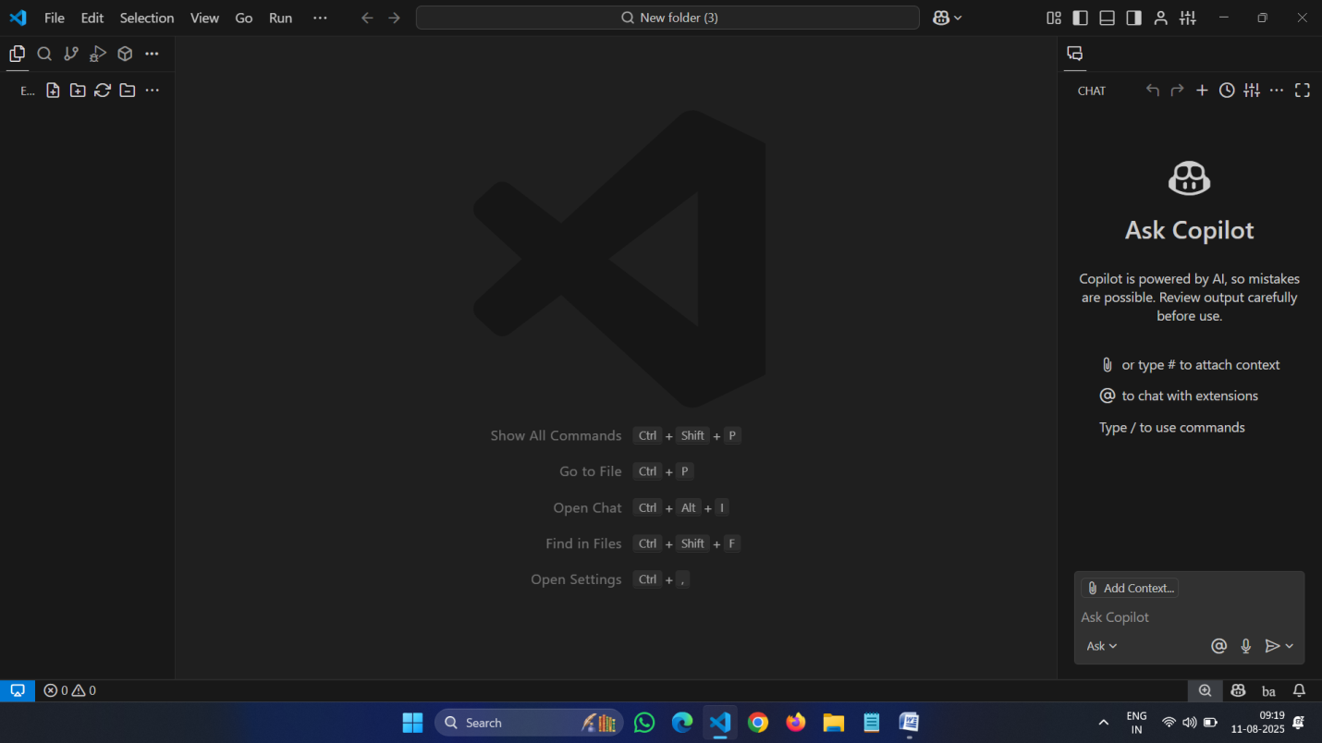

Task 1 : Factorial without function
- Description
Use GitHub copilot to generate a python program that calculates the factorial of number without defining any function using loops directly in the main code.
- Expected output :
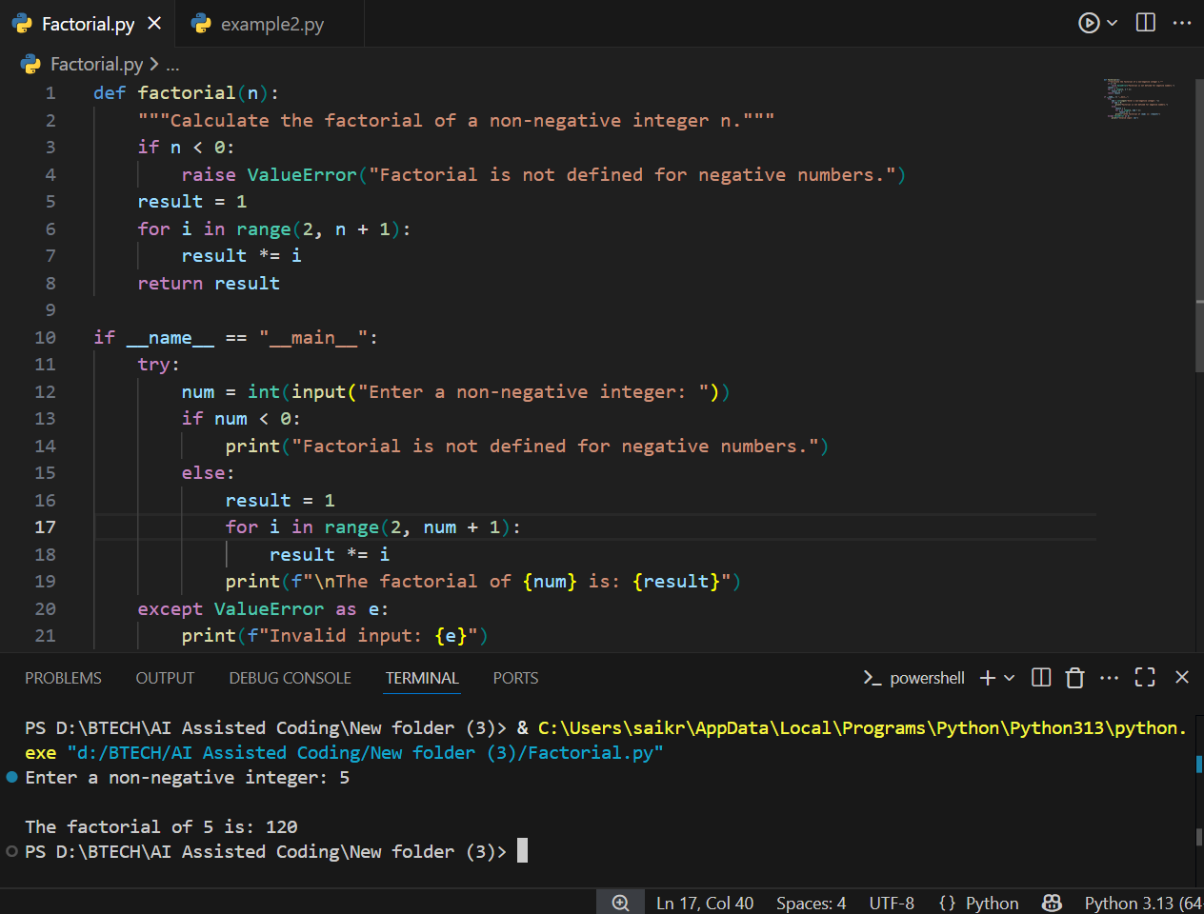

Task 2 :Improving Efficiency
- Description
- Examine the Copilot generated code .

The code is improved by removing the function definition and calculating the factorial directly in the main block using a loop. This reduces function call overhead and simplifies the logic. The while loop starts from 2 and multiplies up to the input number, which is efficient for factorial calculation. Error handling for invalid input is also included.
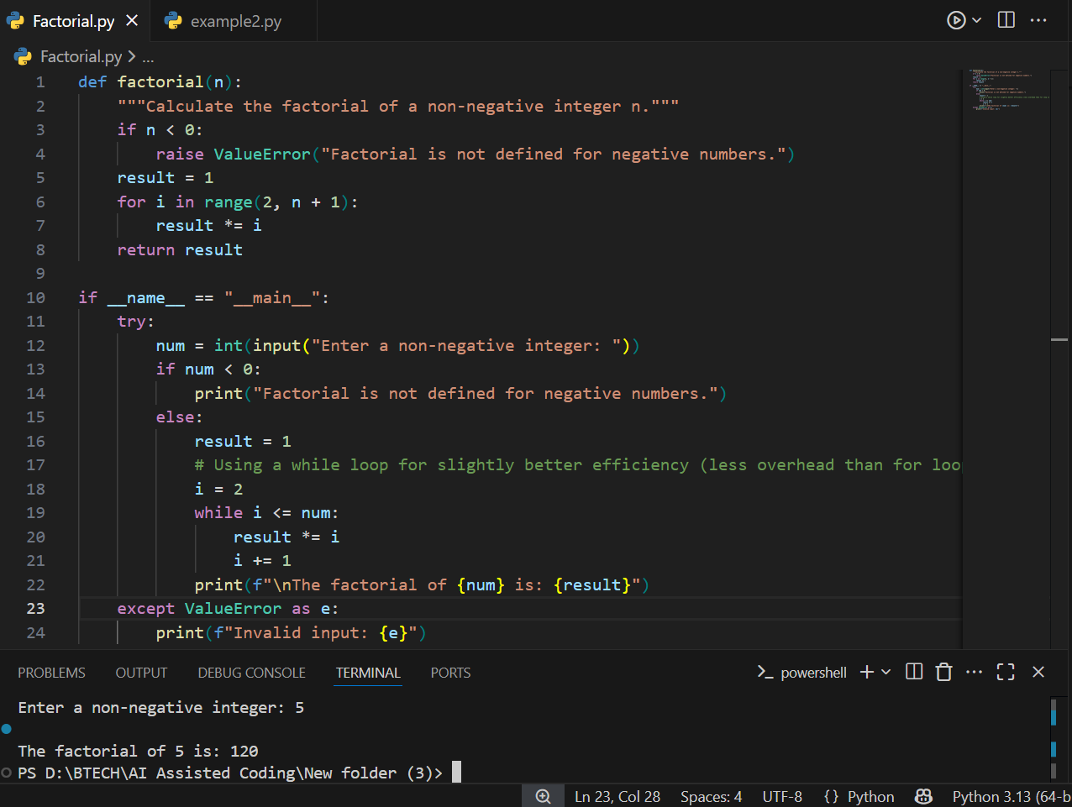

Task 3 :Factorial with functions
- Use GitHub copilot to generate a python program that calculates the factorial of number Using user defining any function
- Expected output :

- Defined a function factorial(n) to calculate the factorial of a non-negative integer.
- Checked if the input n is negative; if so, raised a ValueError.
- Initialized result to 1.
- Used a for loop to multiply result by each integer from 2 to n.
- Returned the computed factorial value.
- In the main block, prompted the user to enter a non-negative integer.
- Called the factorial function with the user input and printed the result.
- Handled invalid input using a try-except block.

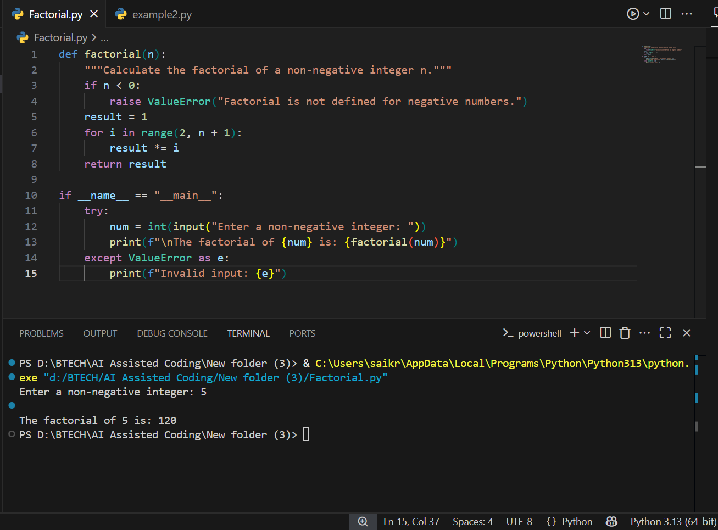

Task 4 : Comparative Analysis – With vs Without Functions
- Description
Differentiate between the copilot generated factoral program with functions and without functions in the terms of logic ,reusability,and execution.
- Expected Output :
  - With functions



- Without functions


Logic
- With Function:
The logic is encapsulated in a user-defined function (factorial(n)), which takes an argument and returns the factorial. The main code calls this function.
- Without Function:
The logic is written directly in the main code block. The loop and calculation are performed inline, without any encapsulation.

2. Reusability
- With Function:
Highly reusable. The factorial function can be called multiple times with different arguments, in other parts of the program or from other modules.
- Without Function:
Not reusable. The code can only be executed as written, and cannot be called with different inputs without rewriting or copying the logic.
3. Execution
- With Function:
Slight overhead due to function calls, but allows for cleaner code, easier testing, and better error handling.
- Without Function:
Executes sequentially in the main block. Slightly faster for very simple scripts due to no function call overhead, but less organized and harder to maintain for larger programs.
Summary:
Using functions improves code organization, reusability, and maintainability, while direct logic in the main block is simpler but less flexible and harder to reuse.

Task 5 :Iterative vs Recursive Factorial
- Description :
Prompt GitHub Copilot to generate both iterative and recursive versions of the factorial function
- Expected Output :

